EXPERIMENTS
NAME:S Surender
REG NO:1924260070
COURSE CODE:DSA0601 DATA HANDLING AND
VISUALIZATION
Set 7 – Customer Demographics Analysis
CustomerID | Age | Gender | Income(in$)
1 | 28 | Female | 50000
2 | 35 | Male | 60000
3 | 42 | Female | 75000
QUESTION 1
Create a bar chart to visualize the distribution of customer ages. Label the axes
and title the chart.
AIM
To create a bar chart to visualize the distribution of customer ages using R.
PROCEDURE
1. Create the customer demographics dataset.
2. Store the Customer ID and Age values.
3. Use the barplot() function to create the bar chart.
4. Label the X-axis and Y-axis.
5. Add a suitable title.
6. Display the chart.
CODE
customer <- data.frame(
Customer_ID = c(1, 2, 3),
Age = c(28, 35, 42),
Gender = c("Female", "Male", "Female"),
Income = c(50000, 60000, 75000)
)
barplot(
customer$Age,





names.arg = customer$Customer_ID,
xlab = "Customer ID",
ylab = "Age",
main = "Distribution of Customer Ages"
)
OUTPUT
Distribution of Customer Ages

1 | 2 | 3
Customer ID
RESULT
Thus, the bar chart representing the distribution of customer ages was successfully
created.




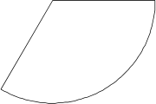

QUESTION 2
Generate a pie chart to represent the distribution of customers by gender.
AIM
To create a pie chart representing the distribution of customers based on gender.
PROCEDURE
1. Create the customer demographics dataset.
2. Count the number of customers in each gender.
3. Use the table() function.
4. Use the pie() function to create the pie chart.
5. Add a suitable title.
6. Display the chart.
CODE
customer <- data.frame(
Customer_ID = c(1, 2, 3),
Age = c(28, 35, 42),
Gender = c("Female", "Male", "Female"),
Income = c(50000, 60000, 75000)
)
gender_count <- table(customer$Gender)
pie(
gender_count,
labels = names(gender_count),
main = "Customer Distribution by Gender"
)
OUTPUT
Customer Distribution by Gender
Female
Male
RESULT

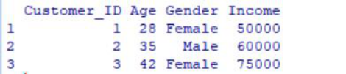

Thus, the stacked bar chart was successfully created to represent product quantities
within different categories.
QUESTION 3
Build a table to show the demographic information for each customer. Label the
table elements.
AIM
To create a table displaying the demographic information of each customer.
PROCEDURE
1. Create the customer demographics dataset.
2. Enter Customer ID, Age, Gender and Income.
3. Assign suitable column names.
4. Display the dataset as a table.
CODE
customer <- data.frame(
Customer_ID = c(1, 2, 3),
Age = c(28, 35, 42),
Gender = c("Female", "Male", "Female"),
Income = c(50000, 60000, 75000)
)
print(customer)
OUTPUT
RESULT
Thus, the scatter plot was successfully created to analyze the relationship between
product price and quantity available.
QUESTION 4

Develop an interactive dashboard combining the bar chart, pie chart, and the
table for interactive exploration of customer demographics.
AIM
To develop an interactive customer demographics dashboard using R Shiny by
combining a bar chart, pie chart and customer information table.
PROCEDURE
1. Create the customer demographics dataset.
2. Load the Shiny package.
3. Create a user interface containing the bar chart, pie chart and table.
4. Create the server section to generate the charts and table.
5. Add a gender filter for interactive exploration.
6. Run the Shiny application.
7. View the dashboard in the browser.
CODE
library(shiny)
customer <- data.frame(
Customer_ID = c(1, 2, 3),
Age = c(28, 35, 42),
Gender = c("Female", "Male", "Female"),
Income = c(50000, 60000, 75000)
)
ui <- fluidPage(
titlePanel("Customer Demographics Dashboard"),
sidebarLayout(
sidebarPanel(
selectInput(
"gender",
"Select Gender:",
choices = c("All", "Female", "Male")
)
),
mainPanel(
plotOutput("agePlot"),
plotOutput("genderPlot"),
tableOutput("customerTable")
)
)
)

server <- function(input, output) {
filteredData <- reactive({
if (input$gender == "All") {
customer
} else {
customer[customer$Gender == input$gender, ]
}
})
output$agePlot <- renderPlot({
data <- filteredData()
barplot(
data$Age,
names.arg = data$Customer_ID,
xlab = "Customer ID",
ylab = "Age",
main = "Distribution of Customer Ages"
)
})
output$genderPlot <- renderPlot({
data <- filteredData()
gender_count <- table(data$Gender)
pie(
gender_count,
labels = names(gender_count),
main = "Customer Distribution by Gender"
)
})
output$customerTable <- renderTable({
filteredData()
})
}
shinyApp(ui = ui, server = server)
OUTPUT

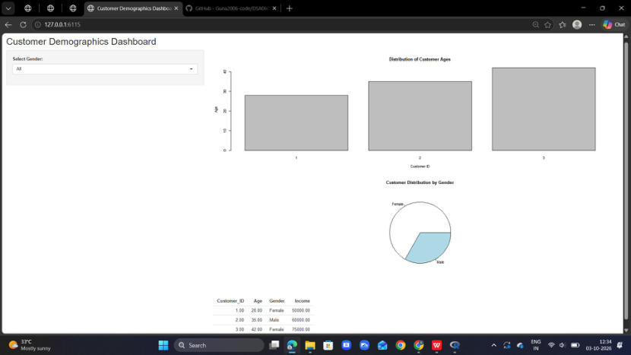

RESULT
Thus, an interactive customer demographics dashboard containing a bar chart, pie
chart and demographic table was successfully created using R Shiny.

